It’s Time to Be a Watchman
by Pastor Fee Soliven
Matthew 24:40-42
Wednesday Evening
November 6, 2022
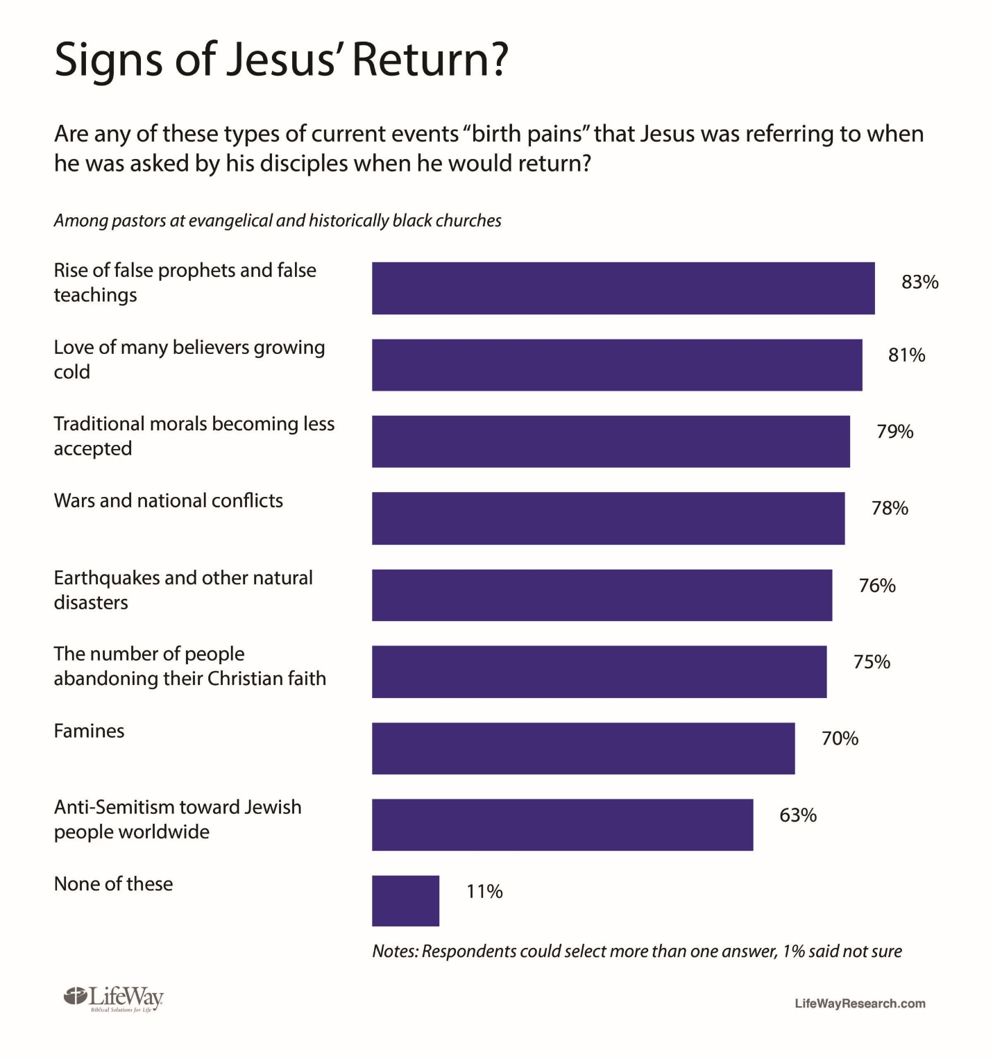

Matthew 24:40-42
40 Then two men will be in the field: one will be taken and the other left. 41 Two women will be grinding at the mill: one will be taken and the other left. 42 Watch therefore, for you do not know what hour your Lord is coming.

Saints, to further illustrate the suddenness of his return, Jesus pictured “business as usual” in Palestine—the men out working in the field; the women doing domestic chores such as grinding grain.

Saints, the Second Coming will happen so suddenly that in the blink of an eye, one of those people may be taken and the other left. The reason? One was ready and one was not. Believers must be on guard and alert, constantly ready for him to come at any time.

1 Corinthians 15:50-58
50 Now this I say, brethren, that flesh and blood cannot inherit the kingdom of God; nor does corruption inherit incorruption. 51 Behold, I tell you a mystery: We shall not all sleep, but we shall all be changed-- 52 in a moment, in the twinkling of an eye, at the last trumpet. For the trumpet will sound, and the dead will be raised incorruptible, and we shall be changed.

53 For this corruptible must put on incorruption, and this mortal must put on immortality. 54 So when this corruptible has put on incorruption, and this mortal has put on immortality, then shall be brought to pass the saying that is written: "Death is swallowed up in victory."

55 "O Death, where is your sting? O Hades, where is your victory?" 56 The sting of death is sin, and the strength of sin is the law. 57 But thanks be to God, who gives us the victory through our Lord Jesus Christ. 58 Therefore, my beloved brethren, be steadfast, immovable, always abounding in the work of the Lord, knowing that your labor is not in vain in the Lord.

Matthew 25:1-13
1 "Then the kingdom of heaven shall be likened to ten virgins who took their lamps and went out to meet the bridegroom. 2 Now five of them were wise, and five were foolish. 3 Those who were foolish took their lamps and took no oil with them,

4 but the wise took oil in their vessels with their lamps. 5 But while the bridegroom was delayed, they all slumbered and slept. 6 And at midnight a cry was heard: 'Behold, the bridegroom is coming; go out to meet him!' 7 "Then all those virgins arose and trimmed their lamps. 8 And the foolish said to the wise, 'Give us some of your oil, for our lamps are going out.'

9 "But the wise answered, saying, 'No, lest there should not be enough for us and you; but go rather to those who sell, and buy for yourselves.' 10 "And while they went to buy, the bridegroom came, and those who were ready went in with him to the wedding; and the door was shut.

11 Afterward the other virgins came also, saying, 'Lord, Lord, open to us!' 12 "But he answered and said, 'Assuredly, I say to you, I do not know you.' 13 "Watch therefore, for you know neither the day nor the hour in which the Son of Man is coming.

Christ’s second coming will be swift and sudden. There will be no time for last-minute repenting or bargaining. The choice that people have already made will determine their eternal destiny.

Matthew 24:43-44
43 But know this, that if the master of the house had known what hour the thief would come, he would have watched and not allowed his house to be broken into. 44 Therefore you also be ready, for the Son of Man is coming at an hour you do not expect.

Saints, Jesus again pointed out the need for constant vigilance. A homeowner cannot know when a burglar might come to break into his home, so he must stay alert. So, it will be with the return of Christ. He will come when least expected.

Ezekiel 33:1-9
1 Again the word of the LORD came to me, saying, 2 "Son of man, speak to the children of your people, and say to them: 'When I bring the sword upon a land, and the people of the land take a man from their territory and make him their watchman, 3 when he sees the sword coming upon the land, if he blows the trumpet and warns the people,

4 then whoever hears the sound of the trumpet and does not take warning, if the sword comes and takes him away, his blood shall be on his own head. 5 He heard the sound of the trumpet, but did not take warning; his blood shall be upon himself. But he who takes warning will save his life.

6 But if the watchman sees the sword coming and does not blow the trumpet, and the people are not warned, and the sword comes and takes any person from among them, he is taken away in his iniquity; but his blood I will require at the watchman's hand.' 7 "So you, son of man: I have made you a watchman for the house of Israel; therefore you shall hear a word from My mouth and warn them for Me.

8 When I say to the wicked, 'O wicked man, you shall surely die!' and you do not speak to warn the wicked from his way, that wicked man shall die in his iniquity; but his blood I will require at your hand. 9 Nevertheless if you warn the wicked to turn from his way, and he does not turn from his way, he shall die in his iniquity; but you have delivered your soul.

Matthew 24:45-47
45 "Who then is a faithful and wise servant, whom his master made ruler over his household, to give them food in due season? 46 Blessed is that servant whom his master, when he comes, will find so doing. 47 Assuredly, I say to you that he will make him ruler over all his goods.

Saints, In ancient times it was a common practice for masters to put one servant in charge of all the household business. The servant, described as faithful and sensible, parallels the disciples, who were given unprecedented responsibility by Jesus.

Yet it also describes those appointed to positions of leadership in the church who should be found faithfully carrying out their duties when Jesus (the master) returns. These servants will be given great rewards.

Proverbs 14:35
"The king's favor is toward a wise servant, But his wrath is against him who causes shame"

Proverbs 28:20
“A faithful man will abound with blessings, But he who hastens to be rich will not go unpunished”

Luke 16:10
“He who is faithful in what is least is faithful also in much; and he who is unjust in what is least is unjust also in much”

Matthew 24:48-51
48 But if that evil servant says in his heart, 'My master is delaying his coming,' 49 "and begins to beat his fellow servants, and to eat and drink with the drunkards, 50 the master of that servant will come on a day when he is not looking for him and at an hour that he is not aware of, 51 and will cut him in two and appoint him his portion with the hypocrites. There shall be weeping and gnashing of teeth.

Saints, some servants, however, might decide to take advantage of their leadership positions, bullying others and indulging themselves.

The servant may have thought his master would be gone a long time, but one day, the master will return unannounced and unexpectedly.

It will be sudden and without warning, and the evil servant will be “caught in the act.” The master’s judgment against his wicked servant will be extremely severe.
Even worse than that horrible punishment will be the servant’s eternal destiny. He will be assigned to a place of weeping and gnashing of teeth (referring to hell). God’s coming judgment is as certain as Jesus’ return to earth.

2 Peter 3:2-13
3 knowing this first: that scoffers will come in the last days, walking according to their own lusts, 4 and saying, "Where is the promise of His coming? For since the fathers fell asleep, all things continue as they were from the beginning of creation." 5 For this they willfully forget: that by the word of God the heavens were of old, and the earth standing out of water and in the water,

6 by which the world that then existed perished, being flooded with water. 7 But the heavens and the earth which are now preserved by the same word, are reserved for fire until the day of judgment and perdition of ungodly men. 8 But, beloved, do not forget this one thing, that with the Lord one day is as a thousand years, and a thousand years as one day.

9 The Lord is not slack concerning His promise, as some count slackness, but is longsuffering toward us, not willing that any should perish but that all should come to repentance. 10 But the day of the Lord will come as a thief in the night, in which the heavens will pass away with a great noise, and the elements will melt with fervent heat; both the earth and the works that are in it will be burned up.

11 Therefore, since all these things will be dissolved, what manner of persons ought you to be in holy conduct and godliness, 12 looking for and hastening the coming of the day of God, because of which the heavens will be dissolved, being on fire, and the elements will melt with fervent heat? 13 Nevertheless we, according to His promise, look for new heavens and a new earth in which righteousness dwells.

I close with 5 Biblical Principles

1. Walk Submissively

One of the most important themes in this book is obedience. It is because of the disobedience of mankind that God will judge the world, and His holy saints are charged repeatedly to distance themselves from the world’s rebellion by “keeping the words” of the book. We are to walk submissively according to God’s Word.

2. Worship Triumphantly

What does it mean to “worship triumphantly”? It means that we grab hold of the truth of God’s Word and give it back in worship to God. We praise His name triumphantly, with exuberance and conviction. Revelation makes it clear that praise and worship are the vital vehicles of our response to all that God is and does.

3. Witness Urgently

Evangelism will one day cease—but not yet. One major purpose of Revelation is to remind sinners that eternal judgment is coming and to stimulate believers to share the Good News of redemption in Jesus’ name.
It is our duty to preach the Gospel, so people may hear and believe the Good News about Jesus, and receive a new nature and a new character.

4. Work Fervently

We have only a little time to work for the advancement of the Gospel, and we must use the time well. We must work, and work hard. The time goes by so quickly! We should remind ourselves that in:

2 Corinthians 5:10
“we must all appear before the judgment seat of Christ, that each one may receive the things done in the body, according to what he has done, whether good or bad”

5. Watch Expectantly

We do not know when the Lord is coming back to this earth. But we do know His arrival is closer today than it was yesterday! He could come at any time to take His Church to His Father’s house. There will be no time to prepare. That is why we must always be ready.

The requirement for salvation is that we take freely what God offers us. He offers us life. He offers us joy. He offers us abundance. He offers us His only Son.

Saints, Soon and Very soon, Jesus is about to appear, we are almost out of here!

1 Thessalonians 4:13-18
13 But I do not want you to be ignorant, brethren, concerning those who have fallen asleep, lest you sorrow as others who have no hope. 14 For if we believe that Jesus died and rose again, even so God will bring with Him those who sleep in Jesus.

15 For this we say to you by the word of the Lord, that we who are alive and remain until the coming of the Lord will by no means precede those who are asleep. 16 For the Lord Himself will descend from heaven with a shout, with the voice of an archangel, and with the trumpet of God. And the dead in Christ will rise first.

17 Then we who are alive and remain shall be caught up together with them in the clouds to meet the Lord in the air. And thus we shall always be with the Lord. 18 Therefore comfort one another with these words.

1 Corinthians 15:50-54
50 Now this I say, brethren, that flesh and blood cannot inherit the kingdom of God; nor does corruption inherit incorruption. 51 Behold, I tell you a mystery: We shall not all sleep, but we shall all be changed-- 52 in a moment, in the twinkling of an eye, at the last trumpet. For the trumpet will sound, and the dead will be raised incorruptible, and we shall be changed.

53 For this corruptible must put on incorruption, and this mortal must put on immortality. 54 So when this corruptible has put on incorruption, and this mortal has put on immortality, then shall be brought to pass the saying that is written: "Death is swallowed up in victory."

Short Movie Slide>
Acts 2:38-39
38 Then Peter said to them, "Repent, and let every one of you be baptized in the name of Jesus Christ for the remission of sins; and you shall receive the gift of the Holy Spirit. 39 For the promise is to you and to your children, and to all who are afar off, as many as the Lord our God will call."
Let’s Pray!

Benediction
"May The LORD bless you and keep you, May The LORD make His face shine upon you, May The LORD be gracious to you, May The LORD lift up His countenance upon you, and give you His (Shalom) peace.” In Jesus Name!

